**CSE1004**

**NETWORKS AND COMMUNICATION**

**REPORT (REVIEW-3)**

**TOPIC:   
Simulate Mobile Adhoc Network (MANET) using ns2**

Under the guidance of

**Dr. Ganesh Gopal D**

**M.S.SANJAY-15BCE0517**

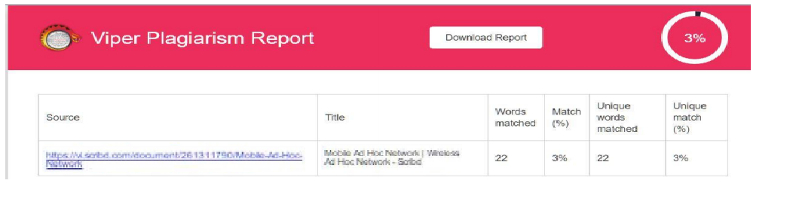**ABSTRACT:**

* Networks that support the ad hoc architecture are typically called wireless ad hoc networks or mobile ad hoc networks (MANET) these two terms are used interchangeably.
* Such networks are typically assumed to be self-forming and self-healing. This project aim is to simulate the wireless ad hoc network using NS2 simulator.
* There is no static infrastructure such as base station. If two hosts are not within radio range, all message communication between them must pass through one or more intermediate hosts that double as routers.

**INTRODUCTION:**

In the recent years, wireless technology has got popularity and usage, thus opening new fields of applications in the domain of networking. The wireless networks may categorize as infrastructure based and infrastructure less network. In infrastructure based networks the mobile nodes are communicated with the help of common access point. Where as in infrastructure less network the mobile nodes are communicated cooperatively with each other, where the participating nodes do not rely on any existing network infrastructure such networks are known as wireless ad hoc networks. In wireless ad hoc networks each node is functions as node as well as router.

Ad hoc networks have a wide array of military and commercial applications. They are ideal in situations where installing an infrastructure network is not possible or when the purpose of the network is too transient or even for the reason that the previous infrastructure network was destroyed.

**AIM:**

We simulate the network which uses AODV as routing protocol and finds the network parameter values and the performance of the AODV protocol is measured.

**OBJECTIVE:**

The objective of the project is to implement Adhoc on demand Distance Vector Routing-aodv protocol in a Mobile Adhoc NETWORK-MANET using network stimulator 2.

**PROJECT SCOPE:**

* Ad hoc networks are very well suited for many situations, in which an infrastructure network can’t be built or it is impossible to build an infrastructure.
* The interest of ad hoc networks increases rapidly in recent year, because ad hoc supports mobility and freedom in the networks.
* Data can be exchanged without cable, access point, or portable memory space.
* Now a day’s computers and phones manufacturers implement ad hoc technology to their products.
* Tactical Networks: -Military communication automated system.
* Entertainment:- Multi users games, Robotics pets.
* Emergency Services: - Disaster recovery, Earth quakes.
* Sensor Network: -Earth activities, Remote weather for sensors.

**HARDWARE/SOFTWARE DESCRIPTION:**

Software used is network stimulator 2.It runs on Linux operating system.

No other special hardware is required.

**PROJECT DESCRIPTION NOTE:**

The project uses ns2 for implementation. Network Simulator version 2 widely known as NS-2 is a discrete event driven network simulation tool for simulation of network to study the dynamic nature of network. Ad-hoc On Demand Distance Vector: AODV is a distance vector type routing. It does not require nodes to maintain routes to destinations that are not actively used. As long as the endpoints of a communication connection have valid routes to each other, AODV does not play a role.

**WHAT IS MANET?**

* A mobile adhoc network (MANET) is a continuously self-configuring, infrastructure-less network of mobile devices connected wirelessly.
* Each device in a MANET is free to move independently in any direction, and will therefore change its links to other devices frequently. Each must forward traffic unrelated to its own use, and therefore be a router. The primary challenge in building a MANET is equipping each device to continuously maintain the information required to properly route traffic.

**Example scenarios for MANET s:**

* Meetings „
* Emergency or disaster relief situations „ Military communications „
* Wearable computers „
* Sensor networks

**TYPES OF AD-HOC NETWORKS:**

* Vehicular ad hoc networks (VANETs) are used for communication between vehicles and roadside equipment. Intelligent vehicular ad hoc networks (InVANETs) are a kind of artificial intelligence that helps vehicles to behave in intelligent manners during vehicle-to-vehicle collisions, accidents.
* Smart phone ad hoc networks (SPANs) leverage the existing hardware (primarily Bluetooth and Wi-Fi) in commercially available smart phones to create peer-to-peer networks without relying on cellular carrier networks, wireless access points, or traditional network infrastructure.
* Internet-based mobile ad-hoc networks (iMANETs) are ad hoc networks that link mobile nodes and fixed Internet-gateway nodes. For example, multiple sub-MANETs may be connected in a classic Hub-Spoke VPN to create a geographically distributed MANET.

**ARCHITECTURE DIAGRAM OF ADHOC NETWORK:**

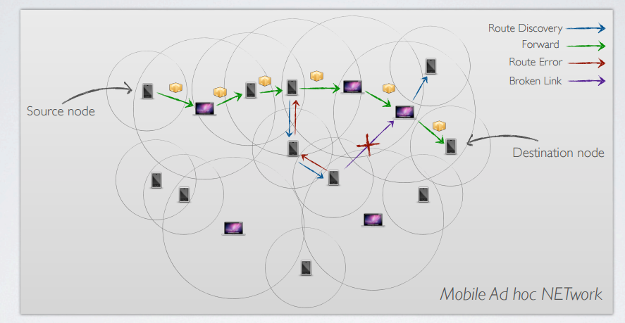

**AD HOC ROUTING PROTOCOLS:**

**Targets:**

Minimize number of exchanged messages

Simplify processing and routing operations

Keeping updated the network scenario

Prevent loops inside the network

**METHODS:**

AODV defines three types of control messages for route maintenance:

**RREQ** - A route request message is transmitted by a node requiring a route to a node.

As an optimization AODV uses an expanding ring technique when flooding these messages. Every RREQ carries a time to live (TTL) value that states for how many hops this message should be forwarded. This value is set to a predefined value at the first transmission and increased at retransmissions. Retransmissions occur if no replies are received.

Data packets waiting to be transmitted(i.e. the packets that initiated the RREQ) should be buffered locally and transmitted by a FIFO principal when a route is set.

**RREP** - A route reply message is unicasted back to the originator of a RREQ if the receiver is either the node using the requested address, or it has a valid route to the requested address. The reason one can unicast the message back, is that every route forwarding a RREQ caches a route back to the originator.

**RERR** - Nodes monitor the link status of next hops in active routes. When a link breakage in an active route is detected, a RERR message is used to notify other nodes of the loss of the link. In order to enable this reporting mechanism, each node keeps a ``precursor list'', containing the IP address for each its neighbors that are likely to use it as a next hop towards each destination

**ALGORITHM:**

Route Discovery:

When a source node needs a route to a destination node and there is not the valid route in the routing table, the source node broadcasts a route request packet (RREQ) to the destination node. When each node receives the RREQ, it creates or updates a reverse route to the source node in the routing table. If it does not have a valid route to the destination node in the routing table, it rebroadcasts the RREQ. When the RREQ flooding from the source node arrives at the destination node, the destination node creates or updates the reverse route. And it unicasts a route reply packet (RREP) which has an incremented the sequence number to the reverse route. When each node receives the RREP, it creates or updates a forward route to the destination node and it forwards the RREP to the reverse route. When the RREP arrives at the source node along with the reverse route, it creates or updates the forward route, and starts communications.

Route Maintenance :

Each node broadcasts a Hello packet periodically for local connectivity. It broadcasts the RREP with TTL=1 as the Hello packet. When the node does not receive any packets from a neighbor during a few seconds, it assumes a link break to the neighbor. In addition, when the node has the link break to the neighbor based on an acknowledgment of MAC layer, it detects a route break to the destination node that the next hop of the route is the neighbor. When the node that detects the link break is close to the destination node (that is to say the number of hops to the destination node is smaller than the number of hops to the source node), it requires a new route to the destination node, which is known as Local Repair.

**CODING:**

set opt(chan) Channel/WirelessChannel ;# channel type

set opt(prop) Propagation/TwoRayGround ;# radio-propagation model

set opt(netif) Phy/WirelessPhy ;# network interface type

set opt(mac) Mac/802_11 ;# MAC type

set opt(ifq) Queue/DropTail/PriQueue ;# interface queue type

set opt(ll) LL ;# link layer type

set opt(ant) Antenna/OmniAntenna ;# antenna model

set opt(ifqlen) 50 ;# max packet in ifq

set opt(nn) 22 ;# number of mobilenodes

set opt(rp) AODV ;# routing protocol

set opt(x) 1800 ;# X dimension of topography

set opt(y) 840 ;# Y dimension of topography

### Setting The Simulator Objects

set ns_ [new Simulator]

#create the nam and trace file:

set tracefd [open aodv.tr w]

$ns_ trace-all $tracefd

set namtrace [open aodv.nam w]

$ns_ namtrace-all-wireless $namtrace $opt(x) $opt(y)

set topo [new Topography]

$topo load_flatgrid $opt(x) $opt(y)

create-god $opt(nn)

set chan_1_ [new $opt(chan)]

#### Setting The Distance Variables

# For model 'TwoRayGround'

set dist(5m) 7.69113e-06

set dist(9m) 2.37381e-06

set dist(10m) 1.92278e-06

set dist(11m) 1.58908e-06

set dist(12m) 1.33527e-06

set dist(13m) 1.13774e-06

set dist(14m) 9.81011e-07

set dist(15m) 8.54570e-07

set dist(16m) 7.51087e-07

set dist(20m) 4.80696e-07

set dist(25m) 3.07645e-07

set dist(30m) 2.13643e-07

set dist(35m) 1.56962e-07

set dist(40m) 1.56962e-10

set dist(45m) 1.56962e-11

set dist(50m) 1.20174e-13

Phy/WirelessPhy set CSThresh_ $dist(50m)

Phy/WirelessPhy set RXThresh_ $dist(50m)

# Defining Node Configuration

$ns_ node-config -adhocRouting $opt(rp) \

-llType $opt(ll) \

-macType $opt(mac) \

-ifqType $opt(ifq) \

-ifqLen $opt(ifqlen) \

-antType $opt(ant) \

-propType $opt(prop) \

-phyType $opt(netif) \

-topoInstance $topo \

-agentTrace ON \

-routerTrace ON \

-macTrace ON \

-movementTrace ON \

-channel $chan_1_

### Creating The WIRELESS NODES

set Server1 [$ns_ node]

set Server2 [$ns_ node]

set n2 [$ns_ node]

set n3 [$ns_ node]

set n4 [$ns_ node]

set n5 [$ns_ node]

set n6 [$ns_ node]

set n7 [$ns_ node]

set n8 [$ns_ node]

set n9 [$ns_ node]

set n10 [$ns_ node]

set n11 [$ns_ node]

set n12 [$ns_ node]

set n13 [$ns_ node]

set n14 [$ns_ node]

set n15 [$ns_ node]

set n16 [$ns_ node]

set n17 [$ns_ node]

set n18 [$ns_ node]

set n19 [$ns_ node]

set n20 [$ns_ node]

set n21 [$ns_ node]

set n22 [$ns_ node]

set opt(seed) 0.1

set a [ns-random $opt(seed)]

set i 0

while {$i < 5} {

incr i

}

### Setting The Initial Positions of Nodes

$Server1 set X_ 513.0

$Server1 set Y_ 517.0

$Server1 set Z_ 0.0

$Server2 set X_ 1445.0

$Server2 set Y_ 474.0

$Server2 set Z_ 0.0

$n2 set X_ 36.0

$n2 set Y_ 529.0

$n2 set Z_ 0.0

$n3 set X_ 143.0

$n3 set Y_ 666.0

$n3 set Z_ 0.0

$n4 set X_ 201.0

$n4 set Y_ 552.0

$n4 set Z_ 0.0

$n5 set X_ 147.0

$n5 set Y_ 403.0

$n5 set Z_ 0.0

$n6 set X_ 230.0

$n6 set Y_ 291.0

$n6 set Z_ 0.0

$n7 set X_ 295.0

$n7 set Y_ 419.0

$n7 set Z_ 0.0

$n8 set X_ 363.0

$n8 set Y_ 335.0

$n8 set Z_ 0.0

$n9 set X_ 334.0

$n9 set Y_ 647.0

$n9 set Z_ 0.0

$n10 set X_ 304.0

$n10 set Y_ 777.0

$n10 set Z_ 0.0

$n11 set X_ 412.0

$n11 set Y_ 194.0

$n11 set Z_ 0.0

$n12 set X_ 519.0

$n12 set Y_ 361.0

$n12 set Z_ 0.0

$n13 set X_ 569.0

$n13 set Y_ 167.0

$n13 set Z_ 0.0

$n14 set X_ 349.0

$n14 set Y_ 546.0

$n14 set Z_ 0.0

$n15 set X_ 466.0

$n15 set Y_ 668.0

$n15 set Z_ 0.0

$n16 set X_ 489.0

$n16 set Y_ 794.0

$n16 set Z_ 0.0

$n17 set X_ 606.0

$n17 set Y_ 711.0

$n17 set Z_ 0.0

$n18 set X_ 630.0

$n18 set Y_ 626.0

$n18 set Z_ 0.0

$n19 set X_ 666.0

$n19 set Y_ 347.0

$n19 set Z_ 0.0

$n20 set X_ 741.0

$n20 set Y_ 152.0

$n20 set Z_ 0.0

$n21 set X_ 882.0

$n21 set Y_ 264.0

$n21 set Z_ 0.0

$n22 set X_ 761.0

$n22 set Y_ 441.0

$n22 set Z_ 0.0

## Giving Mobility to Nodes

$ns_ at 0.75 "$n2 setdest 379.0 349.0 20.0"

$ns_ at 0.75 "$n3 setdest 556.0 302.0 20.0"

$ns_ at 0.20 "$n4 setdest 309.0 211.0 20.0"

$ns_ at 1.25 "$n5 setdest 179.0 333.0 20.0"

$ns_ at 0.75 "$n6 setdest 139.0 63.0 20.0"

$ns_ at 0.75 "$n7 setdest 320.0 27.0 20.0"

$ns_ at 1.50 "$n8 setdest 505.0 124.0 20.0"

$ns_ at 1.25 "$n9 setdest 274.0 487.0 20.0"

$ns_ at 1.25 "$n10 setdest 494.0 475.0 20.0"

$ns_ at 1.25 "$n11 setdest 899.0 757.0 25.0"

$ns_ at 0.50 "$n12 setdest 598.0 728.0 25.0"

$ns_ at 0.25 "$n13 setdest 551.0 624.0 25.0"

$ns_ at 1.25 "$n14 setdest 397.0 647.0 25.0"

$ns_ at 1.25 "$n15 setdest 748.0 688.0 25.0"

$ns_ at 1.25 "$n16 setdest 842.0 623.0 25.0"

$ns_ at 1.25 "$n17 setdest 678.0 548.0 25.0"

$ns_ at 0.75 "$n18 setdest 741.0 809.0 20.0"

$ns_ at 0.75 "$n19 setdest 437.0 799.0 20.0"

$ns_ at 0.20 "$n20 setdest 159.0 722.0 20.0"

$ns_ at 1.25 "$n21 setdest 700.0 350.0 20.0"

$ns_ at 0.75 "$n22 setdest 839.0 444.0 20.0"

## Setting The Node Size

$ns_ initial_node_pos $Server1 125

$ns_ initial_node_pos $Server2 125

$ns_ initial_node_pos $n2 70

$ns_ initial_node_pos $n3 70

$ns_ initial_node_pos $n4 40

$ns_ initial_node_pos $n5 70

$ns_ initial_node_pos $n6 70

$ns_ initial_node_pos $n7 70

$ns_ initial_node_pos $n8 70

$ns_ initial_node_pos $n9 70

$ns_ initial_node_pos $n10 70

$ns_ initial_node_pos $n11 70

$ns_ initial_node_pos $n12 70

$ns_ initial_node_pos $n13 70

$ns_ initial_node_pos $n14 70

$ns_ initial_node_pos $n15 70

$ns_ initial_node_pos $n16 70

$ns_ initial_node_pos $n17 70

$ns_ initial_node_pos $n18 70

$ns_ initial_node_pos $n19 70

$ns_ initial_node_pos $n20 70

$ns_ initial_node_pos $n21 70

$ns_ initial_node_pos $n22 70

#### Setting The Labels For Nodes

$ns_ at 0.0 "$Server1 label Server1"

$ns_ at 0.0 "$Server2 label Server2"

$ns_ at 0.0 "$n2 label node2"

$ns_ at 0.0 "$n3 label node3"

$ns_ at 0.0 "$n4 label node4"

$ns_ at 0.0 "$n5 label node5"

$ns_ at 0.0 "$n6 label node6"

$ns_ at 0.0 "$n7 label node7"

$ns_ at 0.0 "$n8 label node8"

$ns_ at 0.0 "$n9 label node9"

$ns_ at 0.0 "$n10 label node10"

$ns_ at 0.0 "$n11 label node11"

$ns_ at 0.0 "$n12 label node12"

$ns_ at 0.0 "$n13 label node13"

$ns_ at 0.0 "$n14 label node14"

$ns_ at 0.0 "$n15 label node15"

$ns_ at 0.0 "$n16 label node16"

$ns_ at 0.0 "$n17 label node17"

$ns_ at 0.0 "$n18 label node18"

$ns_ at 0.0 "$n19 label node19"

$ns_ at 0.0 "$n20 label node20"

$ns_ at 0.0 "$n20 label node21"

$ns_ at 0.0 "$n22 label node22"

$n2 color green

$ns_ at 0.0 "$n2 color green"

$n3 color green

$ns_ at 0.0 "$n3 color green"

$n4 color green

$ns_ at 0.0 "$n4 color green"

$n5 color green

$ns_ at 0.0 "$n5 color green"

$n6 color green

$ns_ at 0.0 "$n6 color green"

$n7 color green

$ns_ at 0.0 "$n7 color green"

$n8 color green

$ns_ at 0.0 "$n8 color green"

$n9 color yellow

$ns_ at 0.0 "$n9 color yellow"

$n10 color yellow

$ns_ at 0.0 "$n10 color yellow"

$n11 color yellow

$ns_ at 0.0 "$n11 color yellow"

$n12 color pink

$ns_ at 0.0 "$n12 color pink"

$n13 color pink

$ns_ at 0.0 "$n13 color pink"

$n14 color pink

$ns_ at 0.0 "$n14 color pink"

$n15 color pink

$ns_ at 0.0 "$n15 color pink"

$n16 color pink

$ns_ at 0.0 "$n16 color pink"

$n17 color orange

$ns_ at 0.0 "$n17 color orange"

$n18 color orange

$ns_ at 0.0 "$n18 color orange"

$n19 color orange

$ns_ at 0.0 "$n19 color orange"

$n20 color orange

$ns_ at 0.0 "$n20 color orange"

$n21 color orange

$ns_ at 0.0 "$n21 color orange"

$n22 color orange

$ns_ at 0.0 "$n22 color orange"

$Server1 color maroon

$ns_ at 0.0 "$Server1 color maroon"

$Server2 color maroon

$ns_ at 0.0 "$Server2 color maroon"

## SETTING ANIMATION RATE

$ns_ at 0.0 "$ns_ set-animation-rate 12.5ms"

# COLORING THE NODES

$n9 color blue

$ns_ at 4.71 "$n9 color blue"

$n5 color blue

$ns_ at 7.0 "$n5 color blue"

$n2 color blue

$ns_ at 7.29 "$n2 color blue"

$n16 color blue

$ns_ at 7.59 "$n16 color blue"

$n9 color maroon

$ns_ at 7.44 "$n9 color maroon"

$ns_ at 7.43 "$n9 label TTLover"

$ns_ at 7.55 "$n9 label \"\""

$n12 color blue

$ns_ at 7.85 "$n12 color blue"

#### Establishing Communication

set udp0 [$ns_ create-connection UDP $Server1 LossMonitor $n18 0]

$udp0 set fid_ 1

set cbr0 [$udp0 attach-app Traffic/CBR]

$cbr0 set packetSize_ 1000

$cbr0 set interopt_ .07

$ns_ at 0.0 "$cbr0 start"

$ns_ at 4.0 "$cbr0 stop"

set udp1 [$ns_ create-connection UDP $Server1 LossMonitor $n22 0]

$udp1 set fid_ 1

set cbr1 [$udp1 attach-app Traffic/CBR]

$cbr1 set packetSize_ 1000

$cbr1 set interopt_ .07

$ns_ at 0.1 "$cbr1 start"

$ns_ at 4.1 "$cbr1 stop"

set udp2 [$ns_ create-connection UDP $n21 LossMonitor $n20 0]

$udp2 set fid_ 1

set cbr2 [$udp2 attach-app Traffic/CBR]

$cbr2 set packetSize_ 1000

$cbr2 set interopt_ .07

$ns_ at 2.4 "$cbr2 start"

$ns_ at 4.1 "$cbr2 stop"

set udp3 [$ns_ create-connection UDP $Server1 LossMonitor $n15 0]

$udp3 set fid_ 1

set cbr3 [$udp3 attach-app Traffic/CBR]

$cbr3 set packetSize_ 1000

$cbr3 set interopt_ 5

$ns_ at 4.0 "$cbr3 start"

$ns_ at 4.1 "$cbr3 stop"

set udp4 [$ns_ create-connection UDP $Server1 LossMonitor $n14 0]

$udp4 set fid_ 1

set cbr4 [$udp4 attach-app Traffic/CBR]

$cbr4 set packetSize_ 1000

$cbr4 set interopt_ 5

$ns_ at 4.0 "$cbr4 start"

$ns_ at 4.1 "$cbr4 stop"

set udp5 [$ns_ create-connection UDP $n15 LossMonitor $n16 0]

$udp5 set fid_ 1

set cbr5 [$udp5 attach-app Traffic/CBR]

$cbr5 set packetSize_ 1000

$cbr5 set interopt_ 5

$ns_ at 4.0 "$cbr5 start"

$ns_ at 4.1 "$cbr5 stop"

set udp6 [$ns_ create-connection UDP $n15 LossMonitor $n17 0]

$udp6 set fid_ 1

set cbr6 [$udp6 attach-app Traffic/CBR]

$cbr6 set packetSize_ 1000

$cbr6 set interopt_ 5

$ns_ at 4.0 "$cbr6 start"

$ns_ at 4.1 "$cbr6 stop"

set udp7 [$ns_ create-connection UDP $n14 LossMonitor $n4 0]

$udp7 set fid_ 1

set cbr7 [$udp7 attach-app Traffic/CBR]

$cbr7 set packetSize_ 1000

$cbr7 set interopt_ 5

$ns_ at 4.0 "$cbr7 start"

$ns_ at 4.1 "$cbr7 stop"

set udp8 [$ns_ create-connection UDP $n14 LossMonitor $n9 0]

$udp8 set fid_ 1

set cbr8 [$udp8 attach-app Traffic/CBR]

$cbr8 set packetSize_ 1000

$cbr8 set interopt_ 5

$ns_ at 4.0 "$cbr8 start"

$ns_ at 4.1 "$cbr8 stop"

set udp9 [$ns_ create-connection UDP $n4 LossMonitor $n3 0]

$udp9 set fid_ 1

set cbr9 [$udp9 attach-app Traffic/CBR]

$cbr9 set packetSize_ 1000

$cbr9 set interopt_ 5

$ns_ at 4.0 "$cbr9 start"

$ns_ at 4.1 "$cbr9 stop"

set udp10 [$ns_ create-connection UDP $n4 LossMonitor $n2 0]

$udp10 set fid_ 1

set cbr10 [$udp10 attach-app Traffic/CBR]

$cbr10 set packetSize_ 1000

$cbr10 set interopt_ 5

$ns_ at 4.0 "$cbr10 start"

$ns_ at 4.1 "$cbr10 stop"

set udp11 [$ns_ create-connection UDP $n9 LossMonitor $n16 0]

$udp11 set fid_ 1

set cbr11 [$udp11 attach-app Traffic/CBR]

$cbr11 set packetSize_ 1000

$cbr11 set interopt_ 5

$ns_ at 4.0 "$cbr11 start"

$ns_ at 4.1 "$cbr11 stop"

set udp12 [$ns_ create-connection UDP $n9 LossMonitor $n10 0]

$udp12 set fid_ 1

set cbr12 [$udp12 attach-app Traffic/CBR]

$cbr12 set packetSize_ 1000

$cbr12 set interopt_ 5

$ns_ at 4.0 "$cbr12 start"

$ns_ at 4.1 "$cbr12 stop"

#ANNOTATIONS DETAILS

$ns_ at 0.0 "$ns_ trace-annotate \"MOBILE NODE MOVEMENTS\""

$ns_ at 4.1 "$ns_ trace-annotate \"NODE27 CACHE THE DATA FRO SERVER\""

#$ns_ at 4.59 "$ns_ trace-annotate \"PACKET LOSS AT NODE27\""

$ns_ at 4.71 "$ns_ trace-annotate \"NODE10 CACHE THE DATA\""

### PROCEDURE TO STOP

proc stop {} {

global ns_ tracefd

$ns_ flush-trace

close $tracefd

exec nam aodv.nam &

exit 0

}

puts "Starting Simulation........"

$ns_ at 25.0 "stop"

$ns_ run

**CONCLUSION:**

As the objective of this research paper is to simulate the wireless network using network simulator NS2 and to measure the performance of this network using AODV as routing protocol. To measure the performance of AODV we select different performance matrix. The values are obtained from the trace file generated by NS2. Using the AWK script the data is processed and is used to measure the performance of AODV protocol.

**SNAPSHOT OF THE SIMULATED NETWORK:**

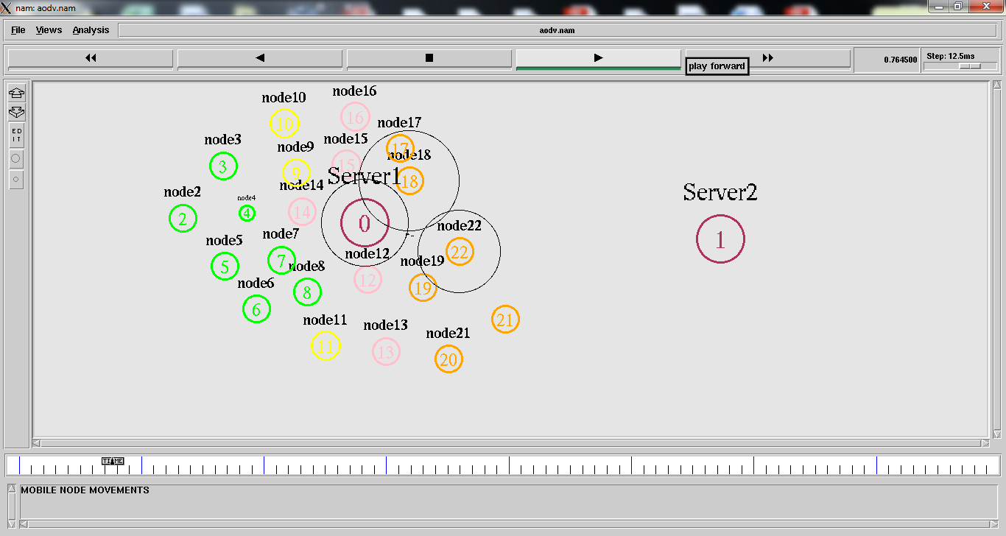

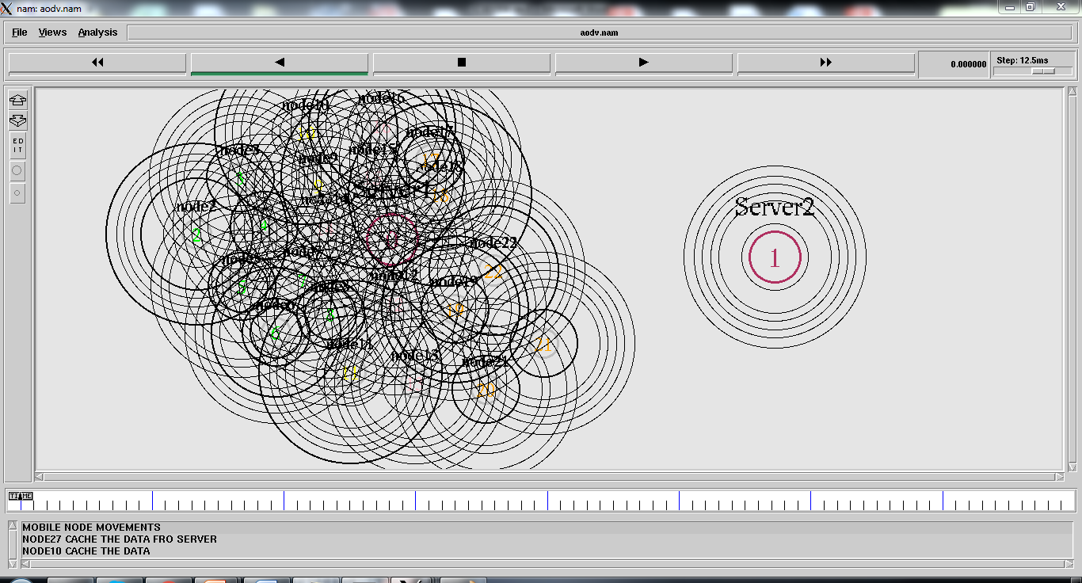

**RESULTS AND DISCUSSION:**

The AODV protocol is successfully implemented for MANET using ns2.It can clearly be seen that AODV has many practical applications in real life.For example, a variation of MANET called Vehicular Ad Hoc Network allows vehicles on roads to communicate within them.If any emergency vehicles like ambulance of fire engine is approaching,it can alert the vehicles ahead of the approaching vehicle so that people could make way for them.It can also be used in WPAN where a small number of devices are connected .This concept can also be used in foggy and dark areas so that vehicles are alerted of nearby vehicles thus avoiding accidents.This concept can also be used in aircrafts so that planes even though they fly through clouds could possibly know nearby aircrafts and thus it can prevent accidents.